How to verify the On-demand Avecto Policy.

1. Select any application and right click

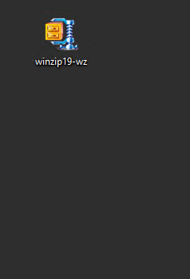

2. Select Run with Privilege Guard (Audited)

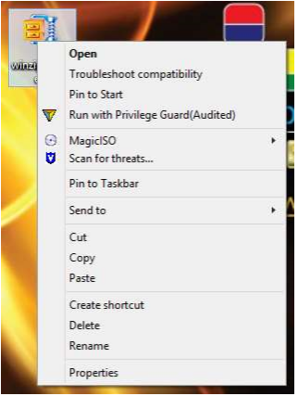

1. Provide your valid reason and complete the installation

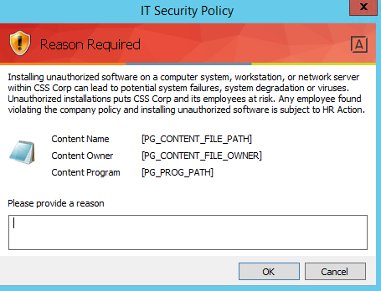

Application uninstallation Steps:

1. Create the Shortcut on the desktop:

Utilities Name: **PGProgramsUtil.exe**

Utilities location:

32 bit OS **C:\Program Files\Avecto\Privilege Guard Client\PGProgramsUtil.exe**

64bit OS: **C:\** **Program Files (x86)\Avecto\Privilege Guard Client\PGProgramsUtil.exe**

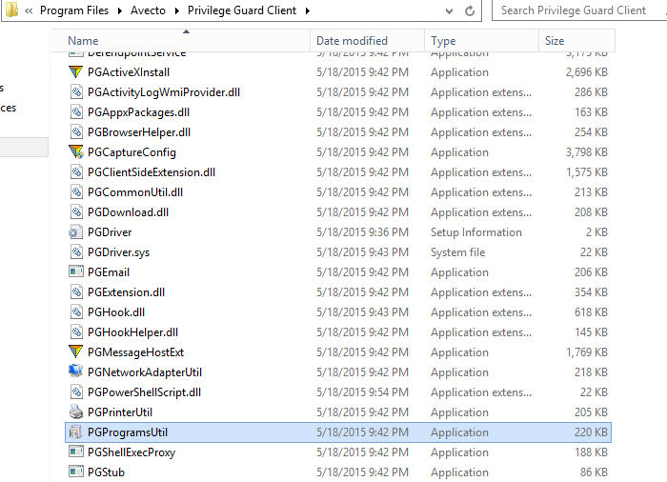

1. Open the shortcut and uninstall the required application:

